Multiple choice section

|  |  |  |  |  |  |  |  |  |  |  |  |
| --- | --- | --- | --- | --- | --- | --- | --- | --- | --- | --- | --- |
| Question | 1 | 2 | 3 | 4 | 5 | 6 | 7 | 8 | 9 | 10 | 11 |
| Answer | A | C | A | C | D | A | B | C | A | A | D |

Question 1 [9.2]

A

Put the data in order.

5 5 6 8 9

The median is the value in the middle; so, 5.

Question 2 [9.2]

C

For Pies it is 25%

For Bombers it is 5%

In total this is 30%

Question 3 [9.7]

A

4 is the only successful outcome; 

Question 4 [9.4]

C

A histogram is the best because grouped measurements are involved.

Question 5 [9.2]

D

Add up the values and divide by 7.

 = 8

Question 6 [9.1]

A

Identify the results in the given range.

44 43 45 45

There are four results.

Question 7 [9.7]

B

Pr(Victor wins) =  × 100% ≈ 39%

Question 8 [9.4]

C

32% of 360° = ≈ 115°

Question 9 [9.5]

A

You can be certain it rained only when the water level rises. This occurred in Weeks 1, 5 and 8.

Question 10 [9.4]

A

Electricity is the first section (36%).

Waste is the top section (3%).

This gives a total of 39%.

Question 11 [9.2]

D

0, 1, 1, 2, 2, 4, 6, 6, 8, 8, 8, 8, 9, 9, 12, 15

There are more 8s than any other number.

Multiple-choice total marks: 11

Short answer section

Question 12

(a) The *mode* of a data set is the result that appears most often.

(b) Numerical data that has a defined number of possible outcomes is called *discrete data*.

(c) If we divide the number of successful outcomes by the total number of outcomes we are finding the *probability* of an event.

Question 13

Both frequency tables and stem-and-leaf plots are ways of grouping data. The biggest difference is that a frequency table will only tell you how many results are in each group, whereas a stem-and-leaf plot maintains the individual data scores. For this reason, a stem-and-leaf plot is often a better choice; however, it takes a little longer to prepare because you need to order the data once you have done the simple grouping stage.

Question 14

(a) Mean:  
 =  ≈ 4.8

(b) Median = 5 since both middle numbers are 5

(c) Mode = 7

(d) Range = 7 – 2 = 5

Question 15

(a) Joanie spent $40 at 11 am.

(b) Joanie withdrew $100 at noon.

(c) Joanie had $80 in her wallet from 9.30 am until 11 am: 1 hours.

(d) Joanie had less than $90 in her wallet from 9.30 am until noon: 2 hours.

Question 16

(a)

|  |  |
| --- | --- |
| STEM | LEAF |
| 0 | 0 0 1 2 4 5 6 6 7 8 9 |
| 1 | 1 3 3 6 8 |
| 2 | 1 2 4 7 |
| 3 | 2 6 |
| 4 | 0 3 |

(b) Median =  = 12

Range = 43 – 0 = 43

On average students in the class did more than an hour of homework on 12 occasions. The spread of data is very large with a difference of 43 between the highest and lowest number of occasions. There is a high proportion of students who did more than an hour of homework on less than 10 occasions.

Question 17

(a)  × 360° ≈ 99°

(b) 1 cm ↔ 100000  
12.76 cm ↔ 1276000  
Make the total length 12.76 cm i.e. about 128 mm.  
1 mm ↔ 10000  
923000 ÷ 10000 = 92.3 ≈ 92 mm

Question 18

NY is, on average, warmer than Paris in summer and colder in winter – so generally more extreme. NY’s median average monthly temperature is 17 °C with a range of 26 °C. Paris’s median average monthly temperature is 16 °C (cooler by just 1 °C) with a range of 17 °C (much less variation).

Question 19

(a) Pr(3) = 

(b) Pr(4, 8, 12, 16, 20) = 

(c) Pr(7, 14) = 

(d) Pr(2, 3, 5, 7, 11, 13, 17, 19) = 

(e) Pr(5, 10, 15, 20) = 

Short answer total: 34

Extended answer section

Question 20

(a) The data is continuous.

(b)

|  |  |  |
| --- | --- | --- |
| Class interval | Tally marks | Frequency |
| 11.5−<12.0 | ⏐⏐ | 2 |
| 12.0−<12.5 | ⏐⏐⏐ | 3 |
| 12.5−<13.0 | ~~⏐⏐⏐⏐~~ | 5 |
| 13.0−<13.5 | ~~⏐⏐⏐⏐~~ ⏐ | 6 |
| 13.5−<14.0 | ⏐⏐⏐ | 3 |
| 14.0−<14.5 | ~~⏐⏐⏐⏐~~ ⏐ | 6 |
|  |  | **25** |

(c)

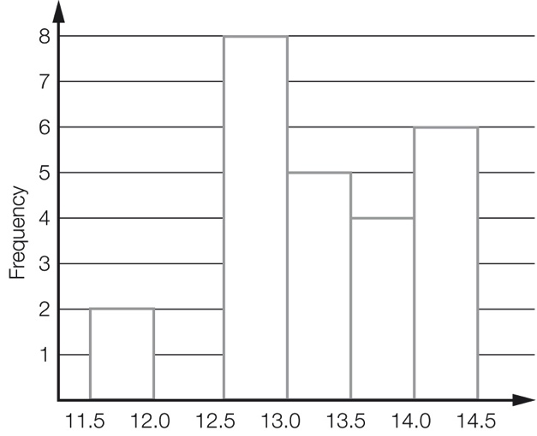

(d) Better than 13.0 seconds:  
 =  =  = 40%

Question 21

(a) 6 + 9 + 5 + 3 + 1 = 24  
Could make the graph 12 cm i.e. 120 mm high. (Other answers possible.)

(b) 1 cm ↔ 2  
4.5 cm ↔ 9  
‘Dog’ would be 4.5 cm i.e. 45 mm high.

(c) Pr(cat) =  = 

Question 22

(a)

|  |  |  |  |  |  |  |
| --- | --- | --- | --- | --- | --- | --- |
|  | 1 | 2 | 3 | 4 | 5 | 6 |
| R1 | (R1, 1) | (R1, 2) | (R1, 3) | (R1, 4) | (R1, 5) | (R1, 6) |
| R2 | (R2, 1) | (R2, 2) | (R2, 3) | (R2, 4) | (R2, 5) | (R2, 6) |
| G1 | (G1, 1) | (G1, 2) | (G1, 3) | (G1, 4) | (G1, 5) | (G1, 6) |
| G2 | (G2, 1) | (G2, 2) | (G2, 3) | (G2, 4) | (G2, 5) | (G2, 6) |
| B | (B, 1) | (B, 2) | (B, 3) | (B, 4) | (B, 5) | (B, 6) |

(b) Pr(R, even) = 

(c) Pr(G, even) = 

(d) The game is fair because Terry has the same chance of winning that Steve has.

(e) Students will provide their own answer, but a sample game would be: Steve wins if green and odd and Terry wins if red and even.

Extended answer total: 20

TOTAL test marks: 65